**ALAGAPPA COLLEGE OF TECHNOLOGY**

**ANNA UNIVERSITY-600025**

**NAAN MUDHALVAN ASSIGNMENT**

**DIGITAL MARKETING**

**Name:** Sharafath Hussain J

**Roll No:** 2020308031

**Department:** B. Tech Pharmaceutical Technology

**College:** Alagappa College of Technology, Anna University.

**Naan Mudhalvan ID:** 7C38C60349803F1BC0E4D5A6D93F5CC1

**Zone:** Zone-1

**Assignment-1:**

Create a company name and design a poster and logo for that company.

Company Name: Jass Roasters Inc

Company Description: Coffee Its meant to be

Company Type: Coffee Roasters

Logo:



Poster:



**Assignment-2:**

Create a blog describing your company.

Blog Link:

[**https://jassroasters.blogspot.com**](https://jassroasters.blogspot.com)

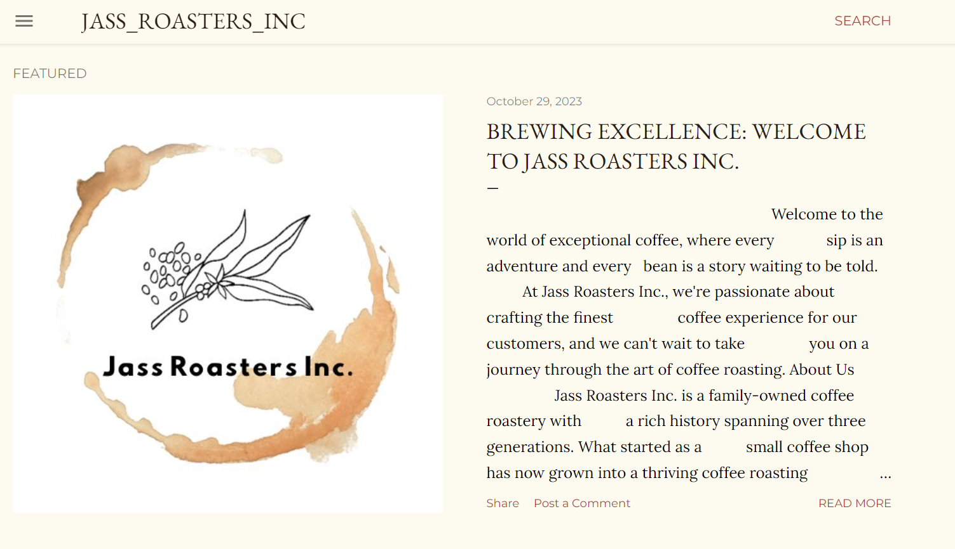

**Assignment-3:**

Create a Facebook account for your company

Facebook ID:

<https://www.facebook.com/JassRoastersInc>

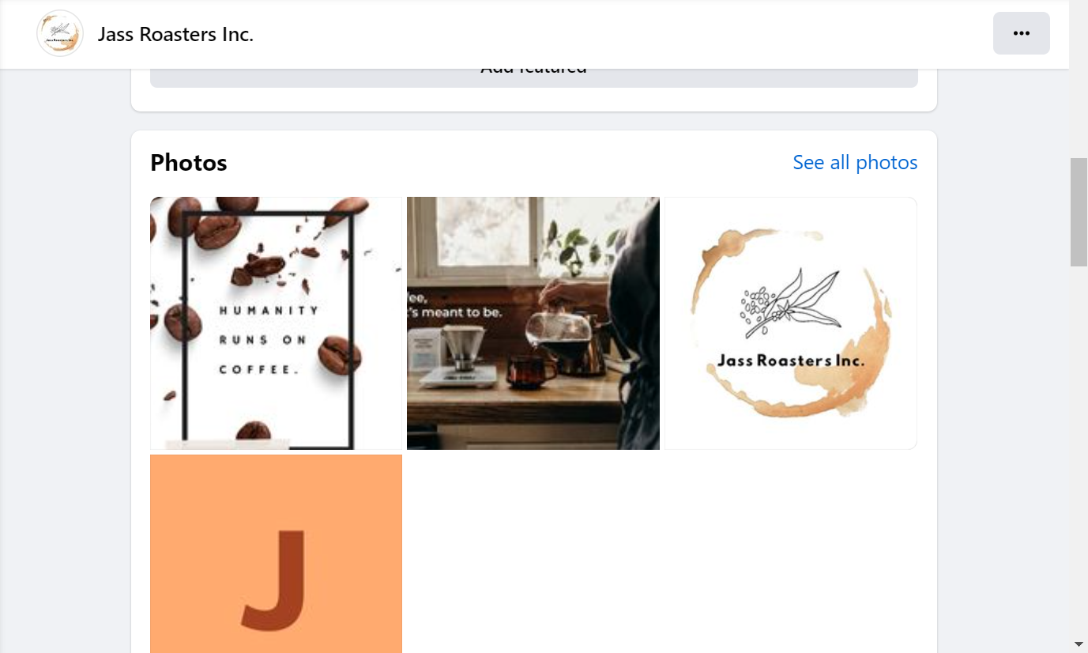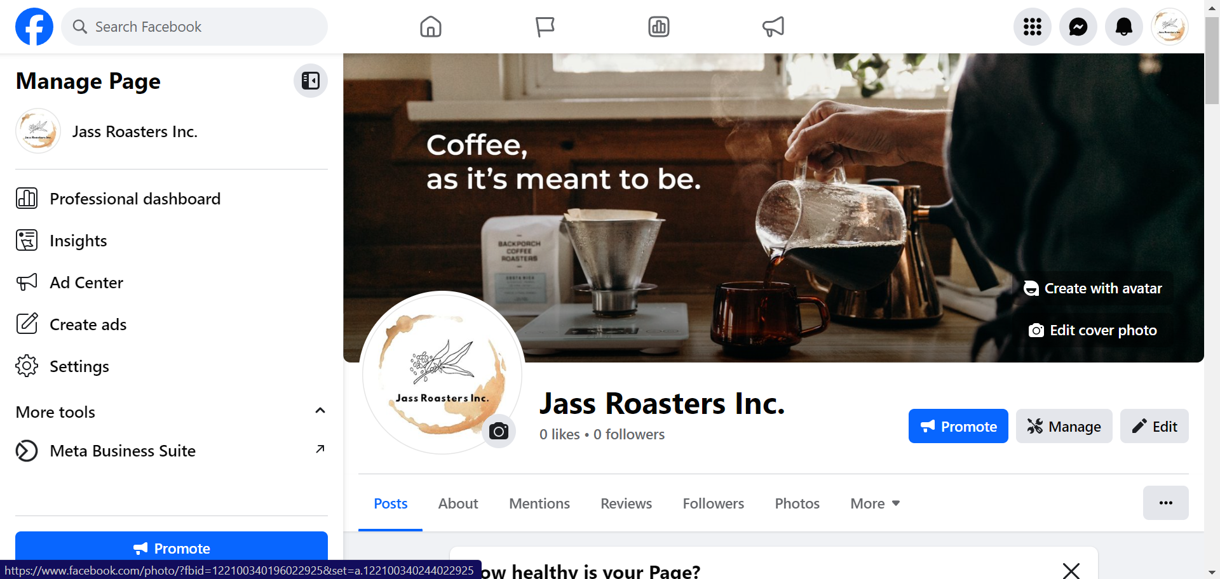

**Assignment-4:**

Create an Email Newsletter for your company and post it in your company blog site. Do google analytics for you blog and send google analytics id.

Google Analytics ID: G-TN805CE340

Email Newsletter link:

<https://jassroasters.blogspot.com/2023/10/savor-worlds-finest-coffee-with-jass.html>

Email Newsletter:

